MARKETING PACKAGES
Epsom Playhouse is keen to work with you to help professionally and effectively market your show or event. This document provides information on the packages available, how the marketing is carried out and what information we need from you to help make your show a success.

Gold Marketing Package £330.00 (Including VAT)
- ‘What’s On Guide’ entry to relevant season, includes hi-res image, show details and show copy/editorial. (Please provide image & copy)
Print run is currently at 35,000 distributed seasonally three times per year.
- 16,000 ‘What’s On Guides’ sent electronically
- Epsom Playhouse website entry (Please see the digital marketing section for image and copy requirements)
- Inclusion in our regular ‘Whats On’ Newsletter E-shot to over 16,000 patrons.
- Facebook post (Like our page at https://www.facebook.com/TheEpsomPlayhouse/)
- Twitter post (Follow us at https://twitter.com/@EpsomPlayhouse)
- Instagram (Follow us at https://www.instagram.com/epsomplayhouse/)
- Facebook boosted post to targeted audience of 1500+
- Press release circulated (Please provide)
- Your banner* displayed prominently outside the venue for a minimum of two weeks before performance. Please contact Fiona for earlier availability.
*Banner must be 3m x 1m to fit display frame. We are unable to display any other size.
- Posters and Flyers displayed in foyer
- A5 size flyers displayed within The Ashley Centre shopping centre.
- Promotional video played in foyer (Please provide a standard DVD)
- Access to online sales data

Silver Marketing Package £250 (Including VAT)
- ‘What’s On Guide’ entry to relevant season, includes hi-res image, show details and show copy/editorial. (Please provide image & copy)
Print run is currently at 35,000 distributed seasonally three times per year.
- 16,000 ‘What’s On Guides’ sent electronically
- Epsom Playhouse website entry (Please see the digital marketing section for image and copy requirements)
- Facebook post (Like our page at https://www.facebook.com/TheEpsomPlayhouse/)
- Twitter post (Follow us at https://twitter.com/@EpsomPlayhouse)
- Instagram (Follow us at https://www.instagram.com/epsomplayhouse/)
- Press release circulated (Please provide)
- Posters and Flyers displayed in foyer
- Your banner* displayed prominently outside the venue for a minimum of 1 week before performance.
- Promotional video played in foyer (Please provide a standard DVD)
- A5 size flyers displayed within The Ashley Centre shopping centre.
- Access to online sales data

Bronze Marketing Package (Digital Only) £50.00 (Inc.VAT)
- Website listing and feature (Please provide hi-res image and copy)
- Inclusion in our regular ‘Whats On’ Newsletter E-shot to over 16,000 patrons.
- 1 Facebook post
- 1 Twitter post

Myers Studio Package £200.00 (Including VAT)
- ‘What’s On Guide’ entry to relevant season, includes hi-res image, show details and show copy/editorial. (Please provide image & copy)
Print run is currently at 35,000 distributed seasonally three times per year.
- 16,000 ‘What’s On Guides’ sent electronically
- Epsom Playhouse website entry (Please see the digital marketing section for image and copy requirements)
- Facebook post (Like our page at https://www.facebook.com/TheEpsomPlayhouse/)
- Twitter post (Follow us at https://twitter.com/@EpsomPlayhouse)
- Instagram (Follow us at https://www.instagram.com/epsomplayhouse/)
- Press release circulated (Please provide)
- Posters and Flyers displayed in foyer
- A5 size flyers displayed within The Ashley Centre shopping centre.
- Access to online sales data

Optional Extras (Including VAT)
- Solus E-shot to Playhouse database (16,500+ patrons) - £120

- Targeted Mailshot - 50p per envelope (Flyer and covering letter)

- Coming soon section of What’s On Guide - £120 (Limited availability – 5 spaces)

- Double Page Spread advertorial within What’s On Guide - £420 (Subject to Availability)

- Single page advertorial within What’s On Guide - £240 (Subject to Availability)

- Facebook Boosted post - (Promoter/production company to decide spend)

- Overprinting Posters/Flyers (if required) - £60

What’s On Guide
Our Epsom Playhouse What’s On Guide runs seasonally three times a year - Spring, Summer and Autumn/Winter editions with 153,000 copies distributed yearly.
To successfully promote your show within our What’s On Guide, we will need to the following information for inclusion:
- Hi-res Images, please provide a selection of suitable images.
- A description of the show, no more than 100 words, including a quote if possible.

Marketing Materials required
We will require the following marketing materials to ensure maximum show presence:
- A5 Flyers x 2000 (Maximum)
- A3 Posters x 10
- A2 Posters x 2
- A1 Poster x 1
- Foursheet x 1 (Optional)
- Pop-Up Banner x 1 (Optional

Overprinting
There are strict guidelines in place covering the use of the Council and Playhouse logos and their placement on publicity material. If you are planning to overprint, please speak to us first in order that we can ensure that the correct templates are provided. We will also require a proof before commencement of the full overprint run.
If you are unable to overprint, the Playhouse has this facility available, however you may be charged for the additional cost.

Digital Marketing
Website – sales and promotion
Website: Monthly statistics show that our website: www.epsomplayhouse.co.uk receives 12,000+ unique visitors per month (as at March 2018).
Epsom Playhouse can feature all shows on the website to aid in the promotion of shows, and to enable online booking. To do this effectively promoters must provide information as specified below to ensure consistency with the house style of the website.
To effectively market online, we will need from you:
- A description of the show and any other details you’d like to be seen on the web entry
- A short and snappy quotation about the show with the author’s name, if available
- Images as per the guidelines below, in jpeg format.
Image | Width | Height | File Size
Banner | 640 pixels | 350 pixels | From 100kb
Listing | 120 pixels | 120 pixels | From 80kb
Listing
Banner & Quotation
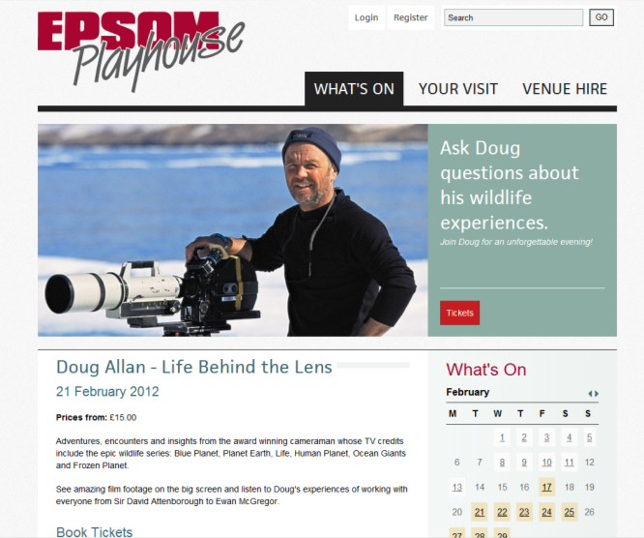
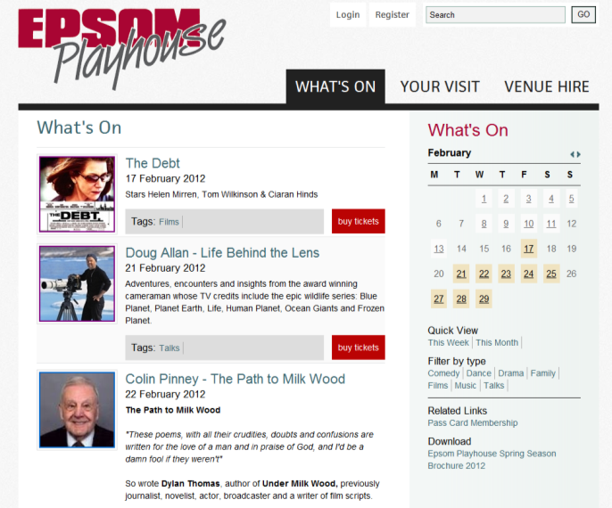

Marketing Contacts
Contact | Email | Phone
Marketing/PR Manager  Fiona Maloney | fmaloney@epsom-ewell.gov.uk | 01372 732 751
Business Development Manager  Russell Blackmur | rblackmur@epsom-ewell.gvo.uk | 01372 732 303

